**Applecross Senior High School**



**Western Australian Certificate of Education**

**Semester One Examination, 2015**

**Question/Answer Booklet**

|  |  |  |  |
| --- | --- | --- | --- |
|  | **Total** | **Result** | **_____%** |
| **Section One** | **52** |  |
| **Section Two** | **98** |  |
| **Total** | **150** |  |

**MATHEMATICS:**

**SPECIALIST**

**UNIT 1**

**Section One:**

**Calculator- free**

**Student’s Name**: **_______________________________________**

**As shown on your exam timetable**

**Student’s Teacher Mr Bellis Mrs Waddell**

(**Circle your teacher’s name**.)

**Time allowed for this section**

Reading time before commencing work: five minutes

Working time for this section: fifty minutes

**Materials required/recommended for this section**

***To be provided by the supervisor***

This question /Answer Booklet

Formula Sheet

***To be provided by the candidate***

Standard Items: pens (blue/black preferred), pencils (including coloured), sharpener,

correction fluid/tape, eraser, ruler, highlighters

Special items: nil

**Important note to candidates**

No other items may be taken into the examination room. It is **your** responsibility to ensure

that you do not have any unauthorized notes or other items of a non-personal nature in the

examination room. If you have any unauthorized material with you, hand it to the supervisor

**before** reading any further.

|  |  |  |  |  |  |  |
| --- | --- | --- | --- | --- | --- | --- |
| Section | Number of questions available | Number of questions to be answered | Working time (minutes) | | Marks available | Percentage of exam |
| Section One:  Calculator-free | 7 | 7 | 50 | | 52 | 35 |
| Section Two:  Calculator-assumed | 13 | 13 | 100 | | 98 | 65 |
|  | | | | **Total** | 150 | 100 |

## Instructions to candidates

1. The rules for the conduct of examinations are detailed in the *School Examination Rules* provided with your exam timetable.Sitting this examination implies that you agree to abide by these rules.
2. Write your answers in this Question/Answer Booklet.
3. You must be careful to confine your responses to the specific questions asked and to follow any instructions that are specific to a particular question.
4. Spare pages are included at the end of this booklet. They can be used for planning your responses and/or as additional space if required to continue an answer.

* Planning: If you use the spare pages for planning, indicate this clearly at the top of the page.
* Continuing an answer: If you need to use the space to continue an answer, indicate in the original answer space where the answer is continued, i.e. give the page number. Fill in the number of the question(s) that you are continuing to answer at the top of the page.

1. **Show all your working clearly**. Your working should be in sufficient detail to allow your answers to be checked readily and for marks to be awarded for reasoning. Incorrect answers given without supporting reasoning cannot be allocated any marks. For any question or part question worth more than two marks, valid working or justification is required to receive full marks. If you repeat an answer to any question, ensure that you cancel the answer you do not wish to have marked.
2. It is recommended that you **do not use pencil**, except in diagrams.
3. The formula sheet and your notes are **not to be handed** in with your Question/Answer Booklet.

Section One: Calculator-free (52 Marks)

This section has**seven (****7)** questions. Answer **all** questions. Write your answers in the spaces provided.

Working time for this section is 50 minutes.

**Question 1 (7 marks)**

(a) Two vectors, **a** and **b** are shown on the grid below.

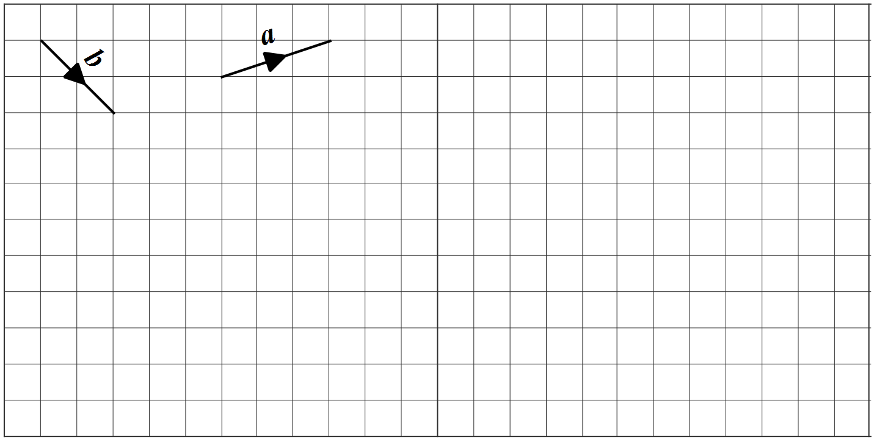

Draw and label the vectors **c** and **d** on the grid,

where $\text{c}=\text{a}+2\text{b}$ and $\text{d}=\text{b}-3\text{a}$. (2 marks)

(b) Determine a unit vector perpendicular to the vector . (2 marks)

(c) The point P divides the line segment from M($-$ 3, 3) to N(13, $-$ 9) in the ratio 1**:**3.

Determine the position vector of point P. (3 marks)

**Question 2 (6 marks)**

The statement ***'If two rectangles are congruent then they have the same area.'*** is true.

(a) Write the inverse of the statement and explain whether or not the inverse is also true.

(2 marks)

(b) Write the contrapositive of the statement and explain whether or not the contrapositive

is also true. (2 marks)

(c) Write the converse of the statement and explain whether or not the converse is also true.

(2 marks)

**Question 3 (6 marks)**

(a) In the diagram below,  and .

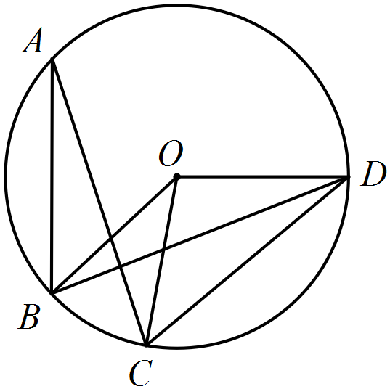

Determine the sizes of

(i) . (1 mark)

(ii) . (1 mark)

(iii) . (1 mark)

(b) Determine, the sizes of the angles marked  and  in the diagram below.

Show your reasoning on the diagram. (3 marks)

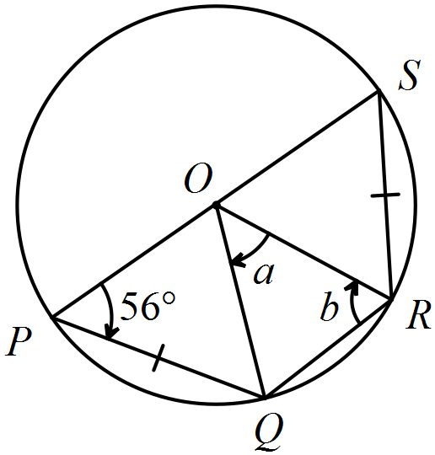

**Question 4 (8 marks)**

(a) Simplify . (2 marks)

(b) Prove that . (3 marks)

(c) Use the result  to determine:

(i)  given that  (1 mark)

(ii)  ,given that  (2 marks)

**Question 5 (9 marks)**

The vectors  are given by  and .

(a) Determine

(i) . (1 mark)

(ii) . (1 mark)

(iii) the vector projection of  onto . (3 marks)

(b) Determine the vectors  if  and . (4 marks)

**Question 6 (7 marks)**

(a) Prove that it is possible to draw a circle through the points , , and  shown below.

(Assume A and B are on a circle and show that C and D must also be on the same circle.)

(3 marks)

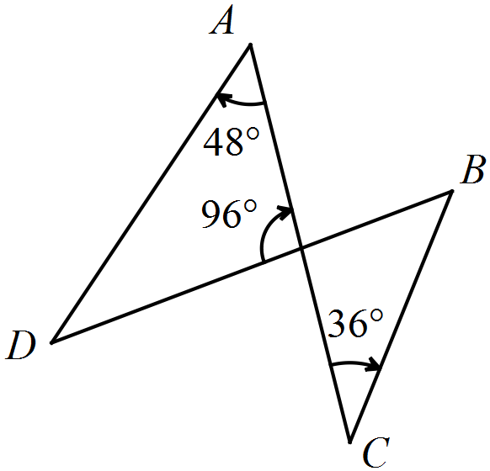

(b) Prove by contradiction that it is impossible to draw a circle through the vertices of the quadrilateral shown below. (4 marks)

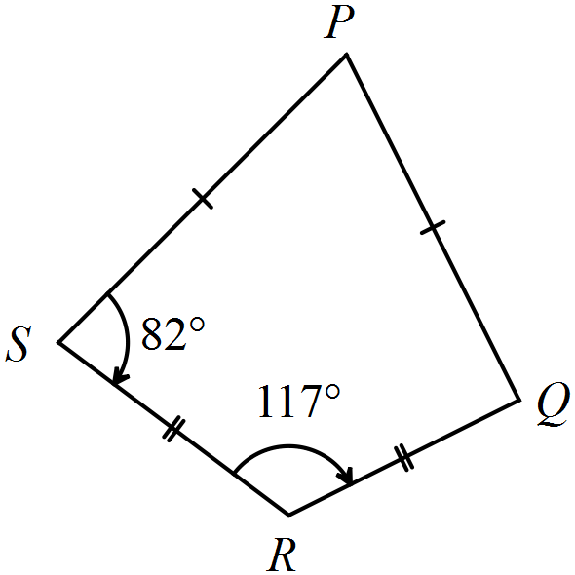

**Question 7 (9 marks)**

(a) A bag contains 17 identical cubes except for their 3 different colours.

There are four coloured orange, six coloured blue and seven coloured white.

(i) How many different arrangements of coloured cubes are possible when three cubes are drawn from the bag and placed in a line? (1 mark)

(ii) How many different combinations of coloured cubes are possible when three cubes are drawn from the bag? (3 marks)

(iii) Determine the least number of cubes that should be removed from the bag to ensure that the resulting selection contains at least three cubes of one colour. Justify your answer. (2 marks)

(b) Find the number of different integers you need to select from the set {1, 2, 3, ..., 98, 99, 100}

so that there is at least one pair of integers with a sum of 99. (3 marks)

**Additional working space.**

**Question Number: _________**

**Additional working space.**

**Question Number: _________**